**How does a company get an idea?**

First, the development company needs to get a main idea. Companies often set up teams of marketing professionals to look for holes in a market, and see what the people are interested in at the moment. The shooters developed between the year 2000 and 2005 were mainly WWII games, but now there is a period of Modern Warfare games. By this I do not mean the Call of Duty series, but actual modern warfare as a setting. These teams create multiple ideas, and try to choose what might be the best option. Another thing they can do is provide the developer with multiple options, and let the developer choose.

The teams set to the task of thinking of ideas is not very simple. There are different things to consider when creating a game. Such things are time-intervals, genre, platform, goals and market. Or even more in-depth: story line, graphics, characters.

Time-intervals is the way a player interacts with other players, non-players(computer controlled characters) or items. There are 3 different types of time-intervals. At first you have a turn-based game, most common in RPG’s. This is when the player is given an amount of time to make a decision while the other player has to wait it’s turn. After one player has chosen what to do and executed this, it is the other players turn to do something. Another time-interval is Real-time. There are no turns in this time-interval. Both players have to react as fast as possible because the other player is busy as well with planning and executing. This is most common in action-games. There also is a time interval type which is limited-turn based. It has the idea of a turn based interval, but the time given for choosing an action is limited. This way there still is pressure behind the player to think fast. This last time interval is actually a mixture of the first 2 intervals.

Genre sounds important, but is not as important as it sounds. Some genres are Puzzle, Serious games(solely educational), Action, Adventure and RPG.

*“I tend to de-emphasize genre in my designing and thinking. I feel that genre is a bit of a double-edged sword for designers. On one hand, genres give designers and publishers a common language for describing styles of play, they for a shorthand for understanding what market a game is intended for, what platform the game will be best suited to, and who should be developing a particular title. On the other hand genres tend to restrict the creative process and lead designers toward tried-and-true gameplay solutions. I encourage students to consider genre when thinking about their games from a business perspective, but not to allow it to stifle their imagination during the design process”*

*-Tracy Fullerton (Associate Professor, USC School of Cinematic Arts; Director, Game Innovation Lab)*

Game Development Essentials, 3rd edition, page 68

The platform is narrowly connected with genre. Would you rather play an 3D adventure game on your phone, or a simple puzzle game? When thinking about consoles, the action game genre is a better choice.

The last main thing to keep in mind is the market you will be developing the game for. Do you want children, young adults, teens or elderly people to play your games? Different age groups play on different platforms. Handhelds such as the game-boys are more for children and young teens, while consoles are more for late teens and young adults. Another thing connected to your market is again genre. Puzzle games are played by another market than FPS games (First-Person shooters).

Last but not least; the goal of your game. Normally when we are discussing games, the games are purely created for entertainment. But you have “Serious Games” as well. These games are created to educate people on certain skills, think of surgery or flying. A well-known type of serious game is a simulator, like Flight Simulator and America’s Army.

You can also go more in-depth such as story line, graphics and characters. Do you want the game to be focussed on the gameplay, such as is the case in modern online multiplayer games, where it is just about winning without any story, or do you want the game to be all around the story. Giving the player a feeling of watching an interactive movie. What will make your game more attractive? As well as the graphics. You have games of cool 3D graphics, but there are also puzzle games in a 2D theme of for example chalk board. Or more in the style of a cartoon, with thick black outlines of the sprite? Characters are important as well. In Real Time Strategy games you often control groups of soldiers for example. You will not make a personal connection to in-game characters. But in games with a main character and a good story line, the player can make a personal connection with the character, even though this can make the character entirely fictional. This is what professional game development companies keep in mind when creating a basic picture of the game.

# How do I get the idea?

When creating a game, there first has to be an idea. For me, this was easy. Before I started this paper on the process of developing a game, I already made a game. As I said in my introduction, I want to redevelop the game to a greater scale, making it more interesting. The original game was created by accident. I tried to develop a game-engine for Physics. I failed, but something else was born. I made an algorithm in such a way, that the algorithm itself would create the movement speed on the x-axis and the y-axis with only given the direction(in degrees) and speed. I could change the direction whenever I liked, and so I created a sort of driving movement. After racing around a bit on an empty screen, I started to think about making some sort of arena. After some useless drawings I created an arena which looked metallic (see figure 2).

C:\Users\Beer\Documents\Visual Studio 2010\Projects\DrivingCar\DrivingCar\DrivingCarContent\Car.pngThe lighter part is where the car should drive in. The darker part I used for decoration and a place to keep track of the scores. After this I created a car.

*Figure 1 – The Original Car Image*

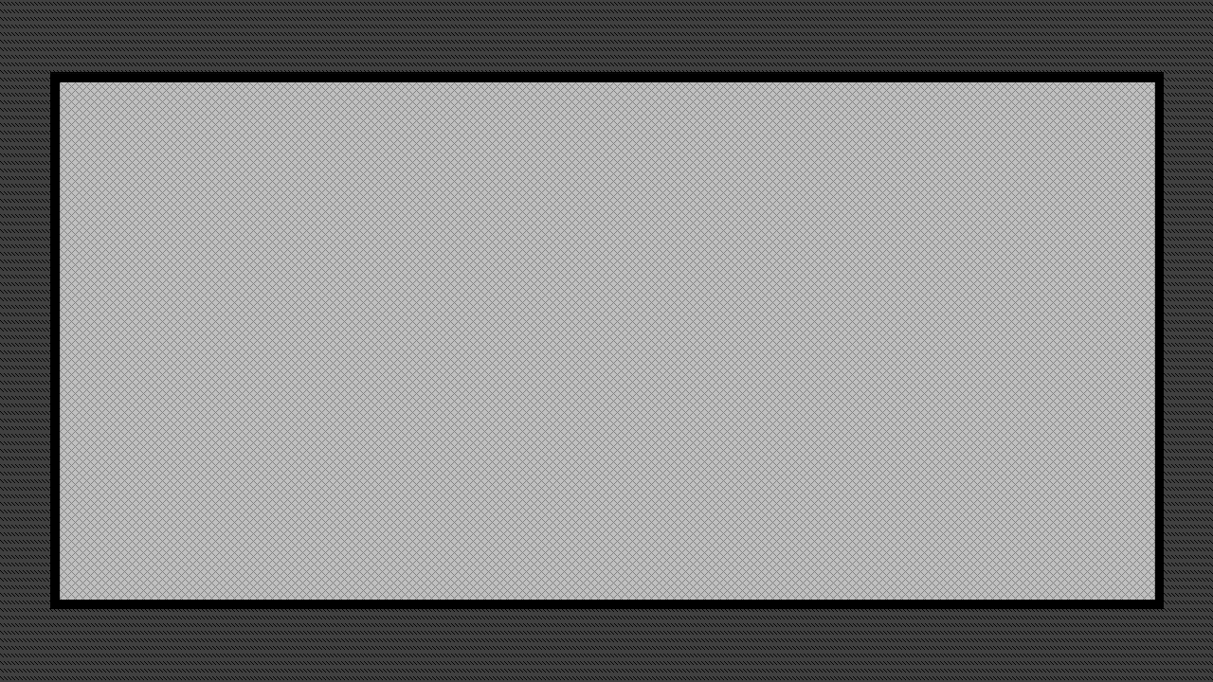  
*Figure 2 – The Original Arena*

By using the framework I programmed in, I could shade the car with any colour I liked. This way I could use the same car over and over but still make a difference between them using different colours. I now wanted to create text (a string in programmer language) to show the score of each player in the screen. I also spawned 2 cars which could drive with a trail of smoke. This together made a simple-looking game altogether (See figure 3). After this I had to create a collision test-algorithm, discussed later in this paper, because the framework did not come with one used for rotated sprites(images).

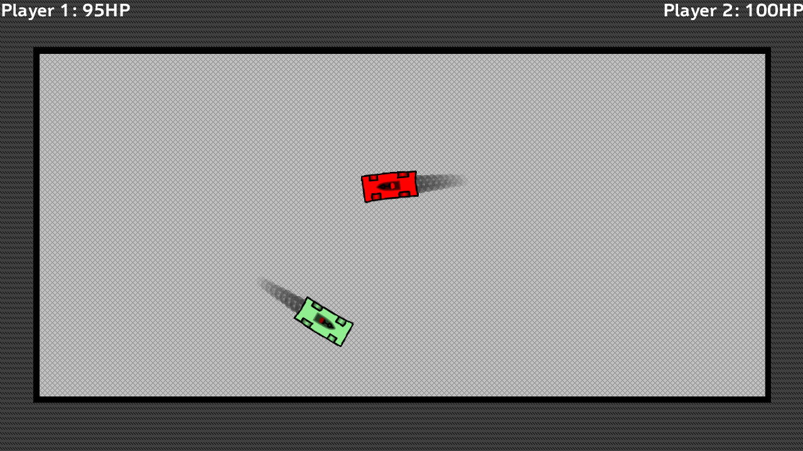I do not have any tactics to try and think of a game. I just watch a movie or am in school for example and suddenly something comes to mind. I remember it and as soon I can reach my PC I immediately start programming.

*Figure 3 – The Game In Progress*

# Comparison

There is a very clear difference between the way a professional developer handles this subject and how I do this. The developer does this very organized and with commercial purposes in mind. I myself get more the idea on impulse. The professional developer uses multiple parameters to come to a decision as I said before, keeping in mind its market. I make a game of what I would like to see, and not to make as much money as possible. The reason for this main difference I think is that I have no budget, and the professional developer does, and I do not want to create this game to generate as much income as possible, but to entertain myself and others.